Basant K. Pradhan, MD
Psychiatrist, Cooper University Health Care - PTSD, Depression, Neuromodulation
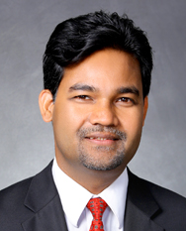

Prior to being immersed into neuropsychiatry and child psychiatry in India and in the US, Basant Pradhan, MD, was a monk. Currently he works in Camden, NJ, at Cooper University Health Care as Vice Chief of Psychiatry and at Cooper Medical School of Rowan University as an Associate Professor of Psychiatry and Pediatrics, and founding Program Director of the brain stimulation, psychedelics, and mindfulness therapy fellowship. Translational research by his group since 2001 has focused on the development of novel protocols by combining the standardized Yoga and mindfulness-based cognitive therapy (Y-MBCT) protocols with medications and targeted brain stimulation for many difficult-to-treat neuropsychiatric conditions including chronic and complex PTSD, treatment resistant depression and Parkinson’s disease, among others. His research has helped advance the understanding of the neurobiology and therapeutics of these disorders and also is aimed at clarifying the pros and cons of psychiatric medications for the young.

