Michael Sabia, MD
Division Head, Pain Management, Cooper University Health Care - Pain and Addiction Mitigation
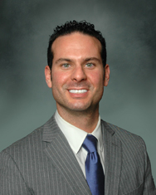

Michael Sabia, MD is a pain management specialist who is Division Head of Pain Management at Cooper University Health Care and an Associate Professor of Anesthesiology at Cooper Medical School of Rowan University. He believes in taking a comprehensive multidisciplinary approach when treating acute and chronic pain.
Dr. Sabia utilizes all resources available when treating pain. These include but are not limited to interventional techniques, physical therapy, acupuncture, medical management, and others.

