Riley Cote
Entrepreneur, Athlete, Wake Advisor
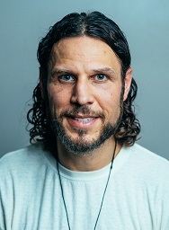
From hockey enforcer to Yogi. Riley Cote played eight years of professional hockey including four with the NHL’s Philadelphia Flyers. His hard style of play eventually took its toll and he decided to retire from playing in 2011 at the ripe age of 28 and committed to a life of mindfulness, healing, and to the integration of sacred plant medicines in his recovery of post-concussion syndrome, PTSD and substance abuse issues. Riley embarked on a quest to use the sports platform to normalize and legitimize the use of entheogens and share his discoveries with the world. Riley is a certified Yoga teacher and teaches meditation and mindfulness under his personal brand Cote Culture. Cote also works with different organizations connecting athletes, first responders and military veterans to psychedelic-assisted psychotherapy with a large focus on mental health and integration. Riley is a partner in Advanced Alchemy Labs which is currently in the process of building out a cannabinoid extraction facility & curriculum with a PA state university (Cheyney University). Riley is also an advisor/investor of Wake Network, a psilocybin & functional mushroom company focusing on precision medicine that supports mental health and brain regeneration.

